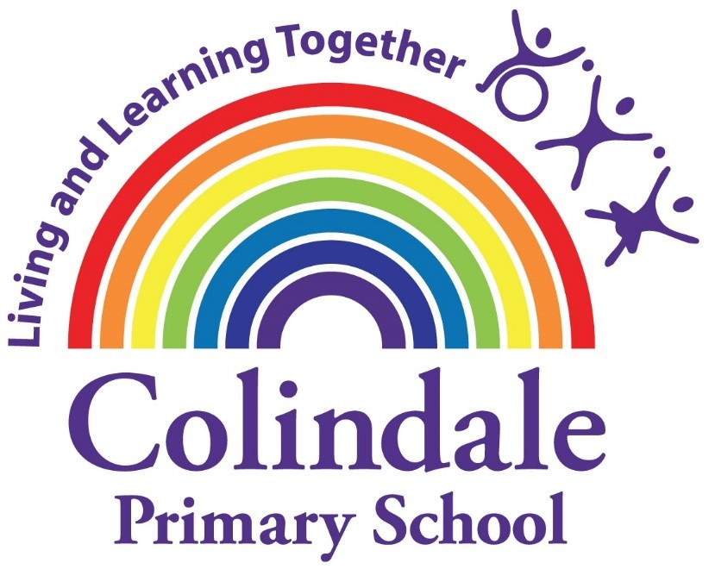

Handwriting Policy

​UNICEF Article 28 Every child has the right to an education. Primary education must be free and different forms of secondary education must be available to every child. Discipline in schools must respect children’s dignity and their rights. Richer countries must help poorer countries achieve his.

Policy last adopted | June 2021
Policy due for review | June 2024

Handwriting in Colindale School June 2021
The skill of handwriting needs to be taught. It is not a natural skill that will grow and develop like speaking. Handwriting is a motor activity, involving fine and gross motor skills. It is a movement stored in the body rather than in the conscious memory. It is in our hands that the kinaesthetic memory lies, which controls the direction and shape of each letter.
Handwriting should be taught explicitly, in short and frequent sessions. The teaching should be based on a style that is quick and easy to learn. It should also be neat, legible and fast. Handwriting should become an automatic process, which frees pupils to focus on the content of their writing.
Handwriting principles:
- It should be modelled by teachers at all times, and then supervised.
- Children should be self/peer assessing, looking for consistency.
- Where possible it should be linked to phonics and spellings.
- When the individual child is ready, they should be practicing on the lines they will be using.
- High expectations of writing are needed in all lessons and homework.
Aims:
- To have a consistent cursive approach across the whole school to ensure high levels of presentation.
- To adopt a common approach towards handwriting by all adults when writing in children’s books, on the whiteboards or on displays/ resources.
- Children to achieve a neat, legible style with correctly formed letters in cursive handwriting.
- Children to develop fluency and speed whilst writing, so that they can eventually write the letters with the confidence and correct orientation.
Putting it into Practise:
- Children can bring in blue pens to try out with their handwriting
- Time tabled handwriting lessons for 10 minutes 3 times a week for both key stages.
- At the latest from the summer term in Year 4, children all children will gain their pen licence.
- From the summer term in Year 4 onwards, all children are expected to write in blue handwriting pens.
- Children should be using the joined up writing in all their school books, including homework.
- Children can bring in their own dark blue pen.
- Staff labels and displays should be produced using the Joinit program.
- Any worksheets could be produced in the handwriting script.
- Teachers to model using the Joinit Program, showing neat and legible handwriting in the joined up script.
- Use the record button on Smart to show joining letters.
- Posture:
Chairs and desks within the classroom should be matched to children’s age and height.
Children’s backs should be straight and feet resting on the floor.
Right and left handed children should be seated to avoid bumping into each other when writing.
Make sure that the hand which is not holding the pencil/pen holds the paper.

Equal opportunities and special needs:
- All children must have the opportunity and the encouragement to reach their full potential.
- Some children can be provided with specialist equipment, such as pencil grips, wider/darker lined paper or a slant for the table.
- Pens with built in grips or non- slippery surfaces can be helpful to some children.
- It may be difficult for left handers to read what they have written, therefore encourage these children to slant their paper slightly at a 30 degree angle, as well as have a higher pen grip. They may also prefer to hold their pen further up
- Extra handwriting groups can be put into place for children who experience significant difficulties to join up.
- Children who have difficulties with their fine motor coordination will have extra support put into place.
- The British Dyslexia Association recommends using a continuous cursive style. By making each letter in one movement, children’s hands are more likely to develop a ‘physical memory’, making it easier to produce the correct shape. Due to the letters and words flowing left to right, children are less likely to reverse letters, which are typically difficult for those with dyslexia (d/b or p/q). With this style there is also a clearer distinction between capital letters and lower case.

Nursery and Reception

So that children can eventually acquire a legible, fluent and fast handwriting style, they need, at an early stage, to develop skills including:

- Good gross and fine motor control closely linked to whole- body movements
- Children are shown how to make large movements in the air with their arms, hands and shoulders.
- Children are then encouraged to develop this in a number of ways including: making letters in sand, shaving foam, bubbles on peoples back etc.)
- In the later stages children begin to recognise patterns
- Develop a language to talk about the shapes and movements of letters
- As children learn their single phonemes they practise writing the graphemes in the pre-cursive style (without the lead in stroke)
- As they learn the digraphs they will then learn to join them.
- Children will also learn to join their names when ready.
- They should experience using a variety of different surfaces to mark on, along with a wide range of tools to mark with. This is to enhance their finger strength which leads onto developing a good pencil grip.
- When children are ready, they will choose which writing implement best suits them, along with which hand they prefer.
- They are taught to hold the pencil between the thumb and forefinger with the pencil resting on the third finger. The thumb and forefinger should also be able to move slightly, so that very fine movements required for writing are possible. This should be monitored.
- Understand which letters belong to which handwriting ‘families’.

By the end of the Reception, most children should be able to use a pencil, as well as hold it effectively to form recognisable letters, most of which are correctly formed.

Key Stage 1

Children practise their handwriting in the back of their English books and are taught handwriting skills in discrete lessons for 10 minutes three times a week.

Year 1:
- In the Autumn term children have the opportunity to practise letter formation with different media, starting with sky writing to reinforce previous learning.
- Children should sit correctly at a table, holding a pencil comfortably and correctly.
- Children learn to form capital letters of the correct size.
- During handwriting sessions children are taught the cursive (joined) handwriting style.
- Depending on their handwriting, children might need to use the dotted letters or the arrowed letters to help with their joins. This might need to carry on into Year 2.
- Use spacing between words that reflect the size of the letters

By the end of Year 1, most children will write in the cursive (joined up) style

Year 2:
- Form lower- case letters of the correct size relative to one another.
- Write capital letters of correct size and orientation in relationship to one another and to lower case letters.

By the end of Year 2, most children can write legibly, using upper and lower case letters appropriately within words, with ascenders and descenders clearly distinguished. They should also be using correct spacing between words. Most children will write fluently in the cursive (joined up) style. The expectation is that this style of writing is applied to all children’s work in all subjects.

Key Stage 2

Throughout Key Stage 2 children practise their handwriting, in discrete handwriting lessons for 10 minutes three times a week. There is a big emphasis on applying handwriting skills to all written work in all subjects. They will work at an individual pace, revisiting and refining their skills. High standards of presentations are valued in each year group in order to encourage children to take pride in their work.

Year 3 and 4:
- Handwriting is done at the back of their English books.
- Increase the legibility, consistency and quality of their handwriting.
- Ensure ascenders do not touch the descenders from the previous line above.
By the end of Year 3, most children can write with consistency in the size and proportion of letters and spacing within words and between words, with ascenders and descenders clearly distinguished, as well as using the correct formation of handwriting joins.
By the end of Year 4, children are expected to write consistently with neat, legible and joined handwriting in all pieces of work.

Year 5 and 6:
- Handwriting is done at the back of their English books.
- Write legibly and fluently with increasing speed and personal style.
- Choosing the writing implement that is best suited for a task (e.g. quick notes).
All children are expected to write in pen. By the end of Year 6, most children have developed a consistent personal handwriting style and some can use different styles for different purposes.

Year group | Progression of skills
Nursery | - Begin to form some recognisable letters  - Begin to write some or all of their name
Reception | - Most children will be able to hold a pencil effectively in preparation for fluent writing- using the tripod grip in almost all cases  - Form recognisable letters, most of which are correctly formed
Year 1 | - Children can write most letters using a comfortable and efficient grip on their pencil  - Letters are correctly formed and orientated and children can put spaces between words  - Letters are correctly joined
Year 2 | - Most children can write legibly, using upper and lower case letters appropriately within words, with ascenders and descenders clearly distinguished  - Correct spacing between words should be used  - Joined handwriting in all pieces of work
Year 3 | - Most children can write with consistency in the size and proportion of letters and spacing within words and between words
Year 4 | - All children are expected to write in blue pen from the start of the year  - Children are expected to write consistently with neat, legible handwriting
Year 5 | - Increasing their fluency and speed  - Most children have developed a consistent personal handwriting style
Year 6 | - Use different styles for different purposes

